private function getLongTitle()

{

return 'There is a very long content for current article, '.'it should be less then ten words';

}

private function getShortTitle()

{

return 'There is a shot title';

}

private function renderContentByModel($title)

{

$model = new Article();

$model->title = $title; if ($model->validate()) {

$content = Html::tag('div', 'Model is valid.',[

'class' => 'alert alert-success',

]);

} else {

$content = Html::errorSummary($model, [

'class' => 'alert alert-danger',

]);

}

return $this->renderContent($content);

}

public function actionSuccess()

{

$title = $this->getShortTitle();

return $this->renderContentByModel($title);

}

public function actionFailure()

{

$title = $this->getLongTitle();

return $this->renderContentByModel($title);

}

}

4. Run the success action of the modelValidation controller by opening the index.php?r=model- validation/success URL, and you’ll get the following:

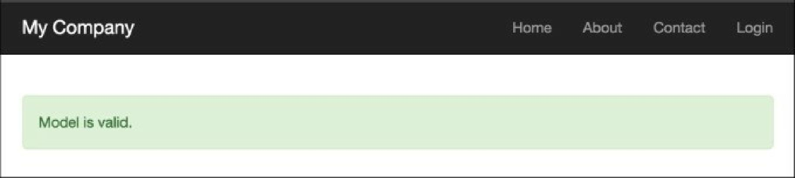

5. Run the failure action of the modelValidation controller by opening the index.php?r=model- validation/failure URL, and you’ll get the following: